IMDB movie review sentiment classification using LSTM

# Dharani Pulimamidi

*700745377*

*dept.Computer Science University of Central Missouri* [Dxp53770@ucmo.edu](mailto:Dxp53770@ucmo.edu)

# Vishnu Ponugoti

*70074450*

*dept.Computer Science University of Central Missouri* [vxp45080@ucmo.edu](mailto:vxp45080@ucmo.edu)

# Ganjai Sai Kumar

*700729622*

*dept.Computer Science University of Central Missouri* [lxg96220@ucmo.edu](mailto:lxg96220@ucmo.edu)

***Abstract*—Nowadays a lot of businesses are looking towards customer satisfaction factors and their opinions.Movie industry is one of them.Sentiment analysis is the most popular technique in deep learning to classify the emotions of any text corpus. Existing methods in sentiment analysis classify the emotions but the results of the classifiers are not satisfactory. The problem with the existing methods is that though this task of classifying the sentiments look simple on the surface this task includes identifying the tone of the sentence, lexicons of the sentence these tasks are easily handled by neural networks.There is a huge impact of reviews on the business 87 percent of the customers/audience are looking for reviews before they finalize purchase of the product or adding the movie to the watch list. Technologies like NLP(Natural Language Processing) and AI(Artificial Intelligence) are evolving with new techniques to solve the problems on text data.Existing solutions for polarity classification concentrate on word level; they do not remember the context of the sentences. They are vulnerable to the new set of sentences and can not generalize the sentences. To overcome this challenge we need a sentence level polarity classification model. In this paper we are proposing a Deep learning LSTM model classify the polarities of the sentences.Experimental analysis is conducted on IMDb dataset.**

1 2 3

***Index Terms*—IMDb(Internet Movie Database), LSTM(Long ShortTerm Memory),Natural Language Processing(NLP), Po- larity classification and (Term Frequency Inverse Document Frequency)**

1. INTRODUCTION

Nowadays a lot of businesses are looking towards customer satisfaction factors and their opinions.Movie industry is one of them.Sentiment analysis is the most popular technique in deep learning to classify the emotions of any text corpus. Existing methods in sentiment analysis classify the emotions but the results of the classifiers are not satisfactory. The problem with the existing methods is that though this task of classifying the sentiments look simple on the surface this task includes identifying the tone of the sentence, lexicons of the sentence these tasks are easily handled by neural networks.

In a novel way instead of using a single neural network for sentiment classification LSTM network .Implementing LSTM-CNN network gives promising results in terms of

1https://github.com/Ganjaisaikumar/NeuralProject

2https://github.com/DharaniPulimamidi/NeuralnetworkProject.git 3https://github.com/Vishnuponugoti/NeuralnetworkProject.git

accuracy and other classification parameters like F1 score. This approach achieved a 91 percent F1 score which deals with the false negatives quantity which is an important measure in classification models like sensitive information.With this performance this can be applied to various scenarios to predict the sentiment of the text. In the sentiment analysis the most important step is word embedding in this paper traditional word embedding methods like word2vectorizer is replaced by a pretrained model that is Glove.Traditional models like word embedding methods produce sparse vectors which con- sumes high memory but they produce embedding for each word in the corpus. Where as Glove eliminates unnecessary space issues .This is implemented using keras library. In this paper they have conducted a comparative study between machine learning techniques and deep learning techniques in sentiment classification. This experiment is conducted using machine learning algorithms SVM,XGBoost,Naive Bayes and logistic regression.In the section of deep learning RNN,CNN and LSTM networks are implemented.In the results analysis Deep learning techniques outperformed the machine learning algorithms . In this paper we propose deep learning meth- ods to perform sentiment analysis on IMDB movie review dataset.Using LSTM and CNN classifier after the training of the model we have calculated the registering time to compare the performance of the model with existing models .

With the revolution of data in every industry there is a huge demand for NLP techniques.Traditional methods in machine learning algorithms i.e classification algorithms are not suit- able for the analysis of sentiments hidden in the text.These algorithms lack feedback blocks in their architecture..Primary task in sentimental analysis is computing the feedback. LSTM networks are an improved version of RNNs.LSTM network contains an extra embedding layer which is helpful to com- pute the feedback.In this project we are proposing a hybrid deep learning model approach to solve the sentiment analysis problem i.e. CNN-LSTM model is considered to be the most efficient model for sentiment analysis. In the first step CNN model is used to classify the sentiments and LSTM text processing. The performance of the model is evaluated with the test sentiment records.For this experiment we have collected the IMDB review dataset from kaggle which is publicly available. Given text is classified into positive or

negative.

In this project all the neural networks are created using keras and Tensorflow libraries. Numpy, seaborn and mat- plotlib libraries are used for mathematical operations and data visualization respectively. The project is developed using Python programming language in google colab and Pycharm environment. For text preprocessing we use beautifulsoup and regex python modules.

Model performance is evaluated using accuracy parameters. Before training the model we apply cross validation to the validation dataset. After the model training we test the model score using the model score function.Confusion matrix is constructed to check the false positives and false negatives of the reviews.Finally a classification report is constructed to check the precision, recall and F1 score of the model.

1. MOTIVATION

In the past the success of movies was spread through word of mouth. With the evolution of the internet people are writing the opinions of their purchases, watching movies and so on. To understand the polarity of the reviews from the huge corpus is a cumbersome task. Understanding the customer.audience pulse is crucial for any business or management. The analysis of the reviews can be done in different ways to understand product trends directly related to the business improvements [1].

There is a huge impact of reviews on the business 87 percent of the customers/audience are looking for reviews before they finalize purchase of the product or adding the movie to the watch list. Technologies like NLP(Natural Language Processing) and AI(Artificial Intelligence) are evolving with new techniques to solve the problems on text data [1]

1. OBJECTIVES

Existing solutions for polarity classification concentrate on word level; they do not remember the context of the sentences. They are vulnerable to the new set of sentences and can not generalize the sentences. To overcome this challenge we need a sentence level polarity classification model [3] . The main objectives of the project are: Building a sentence level polarity classification model which means the model which learns sequentially .

Main features of the project are: For sequential learning we implement the LSTM network for feature extraction. For sequential learning LSTM has following components: Forget gate displays the amount of information retained Input gate how much new information added from current state Cell state is the array LSRM memory Output gate controls how much output is flowed from the gate

1. RELATED WORK

The success of the movie in any industry is decided by word of mouth to a certain extent. With the evolution of social media the talk is spread through this medium. Main medium in the social media which is popular is Facebook. On a daily basis there are billions of posts that go viral on this site. In

this paper we are proposing a A movie success prediction system using facebook posts about the movie success. In this project we have extracted the frequent words that contribute to the success of the movie but we have concluded that solely the posts of facebook can not be used to predict the success of the movie. To predict the success of the movie we used machine learning classifiers which are basic classifiers SVM and Logistic regression. Between the two algorithms SVM algorithm showed superior performance [16].

IMDb is a huge database that stores the information of movies. Every Indian movie review is stored in this website. To decide or predict the movie success we are using is this publicly available data. In our project we are building a system to analyse the sentiments of the movie reviews. Existing systems follow machine learning approaches to predict the success of the movie. In this approach we are implementing the Neural Network approach to find the patterns in the data. We have constructed the CNN model, LSTM model and CNN- LSTM model to evaluate the performance of each model on the benchmark dataset. AMongst these algorithms CNN algorithm showed superior performance [8].

Nowadays people are expressing their views online fre- quently, be it a product they purchased or the movie they watched. This helps the new users to pick their movies and create a watchlist. In this paper we are proposing emotion analysis of the reviews. After the review sentiment analysis we recommend the movies which have positive scores [17].

With the recent developments of machine learning algo- rithms there are several machine learning algorithms that can be applied to text classifications and sentiment analysis. With the evolution of Recurrent Neural networks text classification or analysis of sentiments became easy with their structure of feedback and regularisation parameters. One step ahead of RNN a new architecture is evolved that is LSTM. LSTM contains 4 different gates that can remember the context and sequence of the text. In this method we have observed that the LSTM model achieved 90 percent accuracy on the sentiment analysis benchmark dataset [12].

Text analysis task is very complex to perform since the texts come in different languages and contexts. In the existing system machine learning models are applied to understand the semantics of the text. But the performance of the machine learning models is limited and they do not perform well on the complex datasets. In this paper we are proposing a deep learning model that is Deep Convolutional Neural Networks to extract the features of the sentiments. The main objective of the project is to classify the opinions of the electronic messages as positive or negative. Deep Convolutional Neural Networks achieved 99 percent accuracy on the training data and 90 percent accuracy on the test data. To evaluate the performance of the algorithms we have used IMDB publicly available benchmark dataset [14].

Artificial Intelligence is the main field, machine learning is the sub domain of this field. NLP or Natural Language Processing is the sub field in machine learning which deals with text analytics. Text data comes in different formats

structured, unstructured and semi structured data. In this paper we are conducting the experimental analysis on the benchmark dataset IMDB. To classify the sentiments of the reviews we have used the three different machine learning models Logistic regression, Multinomial Naive Bayes and Linear Support Vector Machine. To find the contexts of the reviews in deep we applied N-gram methods also. After classifying the data a comparative study is conducted to pick the best model. Test performance is measured in terms of F1 score after 10 cross fold validations. After the 10 cross fold validations the model achieved 90 percent accuracy [7].

Though there are ratings factors in the reviews section, sometimes reviews ratings can not give the experience of the user in terms of ratings. In this paper we are proposing the sentiment analysis of the reviews. In this paper we analyse each review sentiment using machine learning algorithms. To reach the analysis of the sentiments we divide the work into 2 parts. In the first part we vectorize the texts using the TFIDF vectorizer that is imported from the scikit-learn library. And to select the important features Information Gain is calculated to train the model insignificant features are discarded. Naive bayes classifiers perform well on the text classification dataset because the word’s probability of occurrence is independent of each other. In this paper we analysed the performance of the model using various accuracy parameters F1 score, recall and precision [10].

Though machine learning algorithms solve the problem of sentiment analysis. Deep learning methods are the new approaches to solve the problem. Deep learning models have advantages over the machine learning models in text analy- sis. Deep learning models automatically provide the feature engineering techniques whereas in machine learning methods we need to do the feature engineering manually which is an additional task [2].

Machine learning mainly focuses on predictive analytics. These predictive analytics can be applied to various industries to predict the future perspective of the items and products. The entertainment industry especially utilises this method to predict the earnings of the movie at the boxoffice and hit or flop. In this paper we are proposing a model which predicts the talk of the movie at the box office. To predict the success or failure of the movie various attributes of the movie are used as the predictors IMDb score, gross earnings, budget, number of reviews. There are several factors in the dataset. With the feature importance technique we have selected the most important factors that contribute to the success of the movie [6].

Though the classification accuracy of the sentiments is high these basic methods of machine learning will not work for general data. To work with the real time data to classify the sentences we need to apply advanced techniques. These advanced techniques will be applied at the text processing level to divide the text into meaningful and important vocabulary. In this paper we are proposing various advanced techniques to process the text like word2vec, Doc2vec.To classify the emotions we have implemented the SVM, ANN and Random

Forest algorithms. In this paper we additionally reviewed the n-grams data also to better understand the word semantics [13]. Advanced machine learning and deep learning methods are ruling the data industry. To understand the text semantics and build the real time applications BERT models are used. In this paper we are proposing a BERT model with n-grams as the hyper parameters. The n-grams of the corpus are divided into unigrams, bigrams and trigrams.To conduct experimental analysis we chose the combination of unigrams and bigrams and the second pair as bigrams and trigrams. In addition to pairs we have individual n-gram methods also. Amongst all the combinations the bigram and trigram combination achieved

the highest accuracy of 95 percent [18].

In this paper we have used a customised dataset from several APIs IMDB,Paytm etc., The collected dataset contains movie name , reviews, ratings of the movie, emojis as a reaction. In this paper we are proposing a hierarchical based clustering algorithm to classify the sentiments. This is done in three stages.first the collected dataset is processed using preprocessing techniques. In the second stage hierarchical clustering is used to extract the features. In the final stage we classify the given reviews into two polarities: positive or negative sentiments. Here the polarity of the sentiment is considered to be the positive if the reviews are good. The polarity of the sentence is considered to be the negative when the reviews are bad [11].

Sentiment analysis is the current popular method to know the business value in the market by analyzing the user feed- back. Sentiment analysis helps the business to know the pulse of the customer and where to improve factors.Using Natural Language Processing(NLP) we can analyze the sentiments underlying the sentences whether positive or negative.New re- search studies show that implementing the hybrid model gives better accuracy than the traditional algorithms. In this paper we are implementing the hybrid classifier which classifies the polarities of the sentiments or texts into positive and negative. The implemented algorithm is the LSTM-Adaboost classifier. This classifier adds the advantages over the LSTM model. The LSTM model is the superior model in text sentiment classification. The accuracy of the model LSTM-CNN further improved by adding the adaboost classifier. When compared to the LSTM-CNN model the LSTM-AdaBoost classifier accuracy is improved by 6 percent [20].

The challenging part in sentiment analysis is that the reviews in these databases do not follow a grammatical structure; users follow their own rules and jargon, so analysing the text reviews becomes tough. In machine learning we have some ways to deal with these problems such as n-gram analysis. So in this paper we have used unigrams , bigrams and trigrams of the benchmark dataset IMDB reviews dataset which is collected from open source repository Kaggle. With this approach we have achieved an accuracy of 90 percent [15].

Social media like Twitter and FaceBook are flooded with millions of posts. With a magnus amount of data. Not only the social media platforms, other e-commerce sites are also filled with the product reviews. Though there is a ratings system on

these sites users reviews provide the broad perspective about the product. The rating system tells the user experience about the product overall. To know the specific details of the products satisfactions business needs to depend on the reviews.In this paper we are presenting the two model sentiment classification from twitter data and IMDB review data about the movies. In this paper we have implemented the Latent Semantic Analysis and Auto regressive sentiment model. These methods are classified as Hit,flop and average.Everyday different kinds data is generated from different entities.In that text data is generated from multiple industries and majority of the text data is gen- erated from the following industries e-commerce sites movie databases.This data is used mainly for sentiment analysis putting NLP(Natural Language Processing) to work.Nowadays a lot of businesses are looking towards customer satisfaction factors and their opinions.Movie industry is one of them.In our project we have collected the reviews from the Internet Movie Database(IMDB) dataset from kaggle to analyze the sentiments of the reviews.The objective of the project is to classify the given review into positive or negative using Multinomial Naive Bayes and Stochastic Gradient Descent algorithms [9]. In this paper we are proposing a sentiment analysis model using the ratings system used in the IMDB dataset. The size of the dataset is huge with 50k reviews of both positive and negative. The polarity of the reviews are divided into equal sizes that are 25k each category. The review ratings are given on the scale of 0-5 here 0 indicates the highly disliked and 5 means highly liked. Various machine learning algorithms are applied on this data. Deep learning models LSTM and CNN are considered to be the highest accuracy giving models. In this paper we are proposing text sentiment analysis using a combined CNN and LSTM model. In this paper multiple branches of the CNN and LSTM models are proposed. We optimised the architecture of LSTM-CNN model with different kernels, regularisation parameters and network structure [4].

In this paper we are proposing a bipolar classification algorithm to classify the sentiments of the reviews. After classifying the sentiments of the reviews we classify the success of the movie before the pre release event. To predict the success or failure of the movie we considered the following attributes: budget, cast and crew, language , director popularity. To classify the success of the movie we have implemented the C4.5 and PART algorithms [19].

As per the recent research Naive Bayes classifier is the best performing algorithm on the text dataset. Naive Bayes classifier is the probability dependent classifier and the prob- ability of the classifier is independent of the other class probabilities. In this paper we are proposing a Naive Bayes classifier which classifies the polarity of the reviews. The reviews are processed using Bag of Words(BoW) and TF IDF vectorizer [5]. Everyday different kinds data is generated from different entities.In that text data is generated from multiple industries and majority of the text data is generated from the following industries e-commerce sites movie databases.This data is used mainly for sentiment analysis putting NLP(Natural

Language Processing) to work.Using NLP drawing meaningful insights makes the businesses understand the brand value in the market.The text is classified using the 2 best text classification models Multinomial Naive Bayes and Stochastic Gradient Descent algorithms. SGD is an efficient approach for classification tasks that uses the convex loss functions such as (linear) Support Vector Machines and Logistic Regression. SGD can be efficiently applied to large-scale and sparse machine learning problems that can be encountered in text classification and natural language processing. In addition to SGD, Multinomial Naive Bayes algorithms also outperform the traditional algorithms in text classification. Multinomial Naive Bayes algorithm is a probabilistic learning method that is mostly used in Natural Language Processing (NLP). The algorithm is based on the Bayes theorem and predicts the tag of a text such as a piece of email or newspaper article.Multinomial Naive Bayes classifier achieved 73 percent accuracy on the small text dataset for news classifier where as Bernoulli Naive Bayes classifier achieved 69 percent accuracy on the same dataset [1] [3].

1. DATA DESCRIPTION

The IMDB dataset is collected from open source reposi- tory Kaggle. Dataset contains 50k reviews from the movie database; these are high polarity reviews. The whole dataset is divided into training and testing with equal distribution of 25k each. Attributes in the dataset are text body and polarity of the review. Polarities of the reviews are:positive and negative.

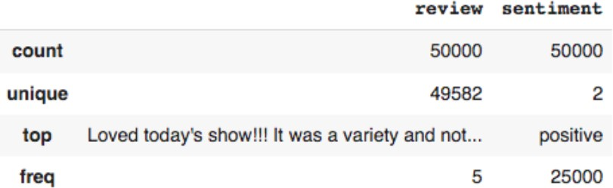

Figure 1. Statistical overview of dataset

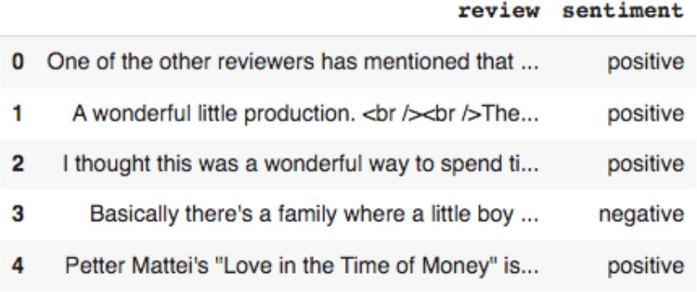

Figure 2. sample view of dataset

1. PROPOSED FRAMEWORK

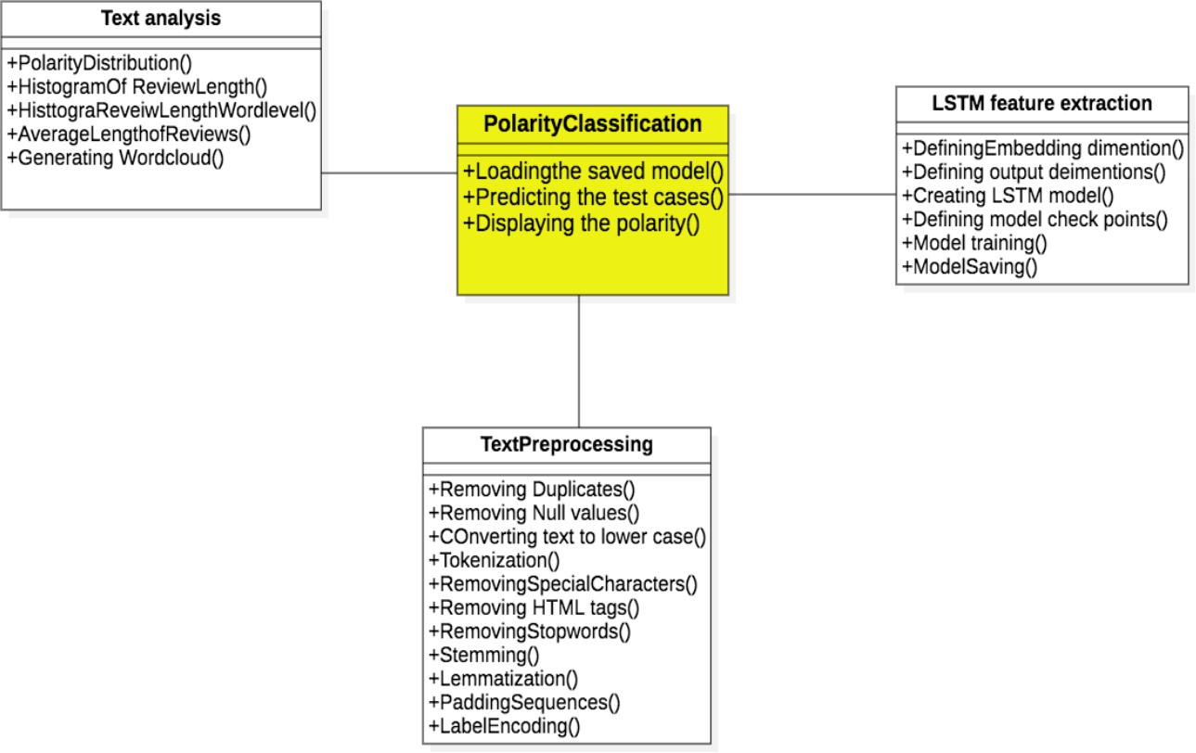

Figure 3. Workflow

The implementation of the project is divided into 4 stages:

1. *Text analysis:*

In the text analysis part we visualize the histograms for word length and sentence length and character length and average length of the sentence in the corpus. We have generated the wordcloud to understand the frequent words in both classes.

1. *Text preprocessing:*
   * n any NLP task text preprocessing the important steps this removes the unnecessary parts from the text and retains the important contexts
   * This is subdivided into following tasks: Removing the stop words from the sentences we have list of stop words in the NLTk library.Stopwords are the list of words which do not carry prominent meaning
   * Removing null values from the records
   * Removing the duplicate rows
   * We convert all the text to lower cases
   * Using snowball stemmer we stem the sentences
   * Encode the categorical target column
   * We split the data into training and testing
   * We get the maximum length of the sequence to convert the each training input length is same for this task we pad the sequences using padding method
   * We remove the html tags and special characters from the sentences before we feed the network
2. *LSTM model implementation:*

After the preprocessing and data preparation we construct the LSTM model to extract the features. We have created the model checkpoint to save the best model We trained the model for epochs for each epoch we have recorded the model training accuracy,loss , validation accuracy and validation loss After completing 10 epochs model achieved 90 percent accuracy on training data 84 percent on validation data

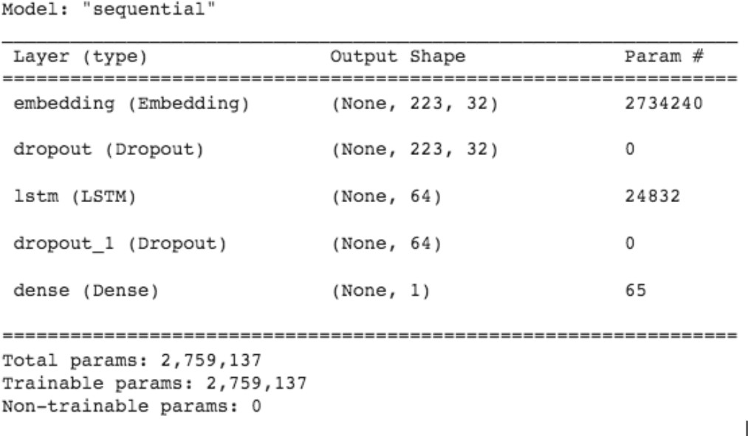

Figure 4. LSTM architecture

1. *Exploratory Data Analysis*

Preliminary results summary: The sentiments positive and negative categories are balanced Histogram shows that the review lengths are between 0-7000 characters and most of the words are between 0-2000 characters The histogram shows the distribution of words in the reviews .Most of the reviews are present 0-300 words Average length of the reviews is 4-6 lines

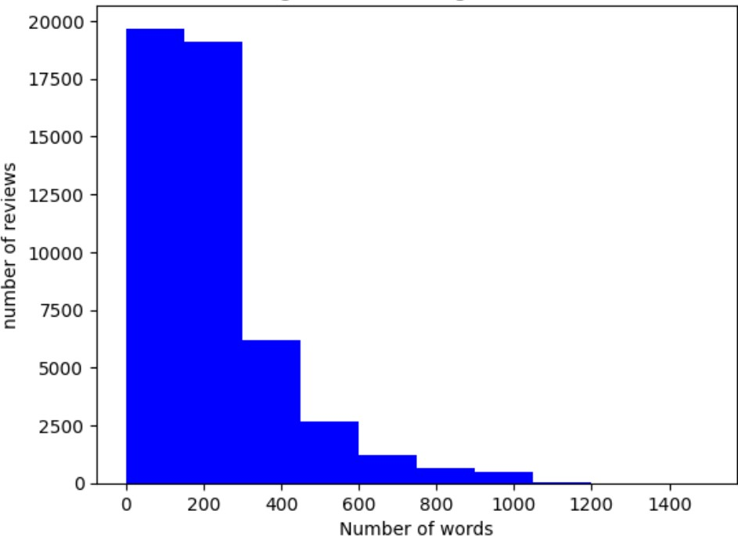 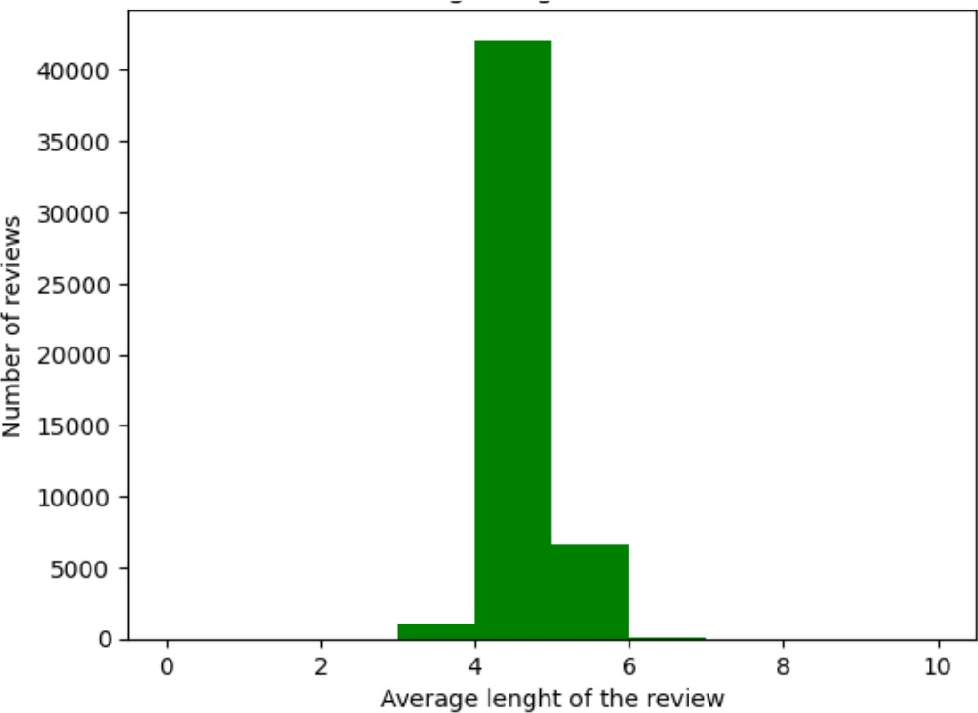

Figure 5. word level distribution Figure 7. Average length of sentences

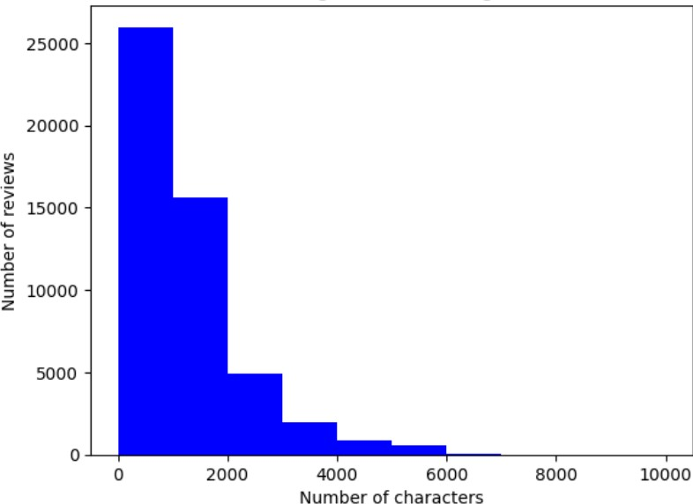

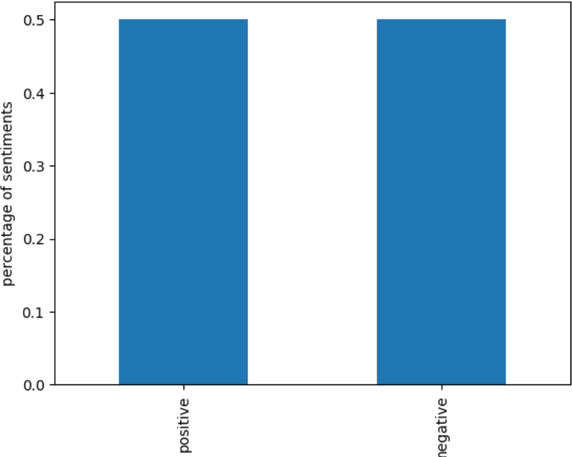Figure 6. Targets distribution

1. RESULTS ANALYSIS

For the results analysis we have published the accuracy plot of the model and classification report: From the classification

Figure 8. Character level distribution

report we can observe that the model is overfitting. There are no “negative” sample predictions in the test data.

LSTM model is constructed with the following layers: The first layers is the embedding layer. In this layer we define the total number of words, embedding dimensions and maximum length of the input.In the second layer we have added the Dropout layer with the dropout value 0.2 followed by a LSTM

layer. In the fourth layer we have added the dropout layer with the value 0.2.In the output layer we have added the dense layer with the parameters optimiser as ’Adam’, loss function as binary cross entropy and the accuracy metric. To measure the performance of the LSTM model accuracy plot is visualized for each epoch. Total number of epochs are 10. In the accuracy plot training accuracy and validation accuracy is displayed. Training accuracy of the model is 89 percent and the validation accuracy is 84 percent. To measure the performance in deep we have contructed the classification report and confusion matrix. Classification report displays the precision, recall and F1 score of the model. To furhter evaluate the model test set we have constructed the confusion matrix. Confusion matrix gives the quantity of the False positives and False negatives.

In the classification report we can see that the model got overfitting problem there are no predictions for once class that is negative. In future we are going to overcome this problem by tuning the parameters. The precision, recall and F1 score of the project are 0.5,1,0.67 for positive class and the negative class the accuracies are 0. The confusion matrix displays the classifications of true positive and true negatives. The confusion matrix and the classification report are deployed from the scikit-learn python opensource library.In the confusionmatrix the diagonal values are true positives or true negatives.Other columns represents the false positives and false negatives in the predictions.

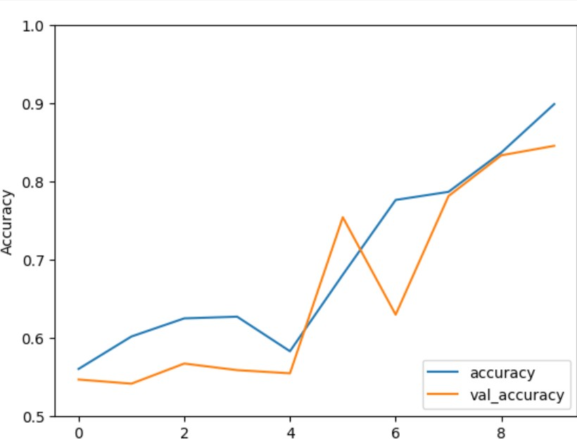

Figure 9. LSTM accuracy plot

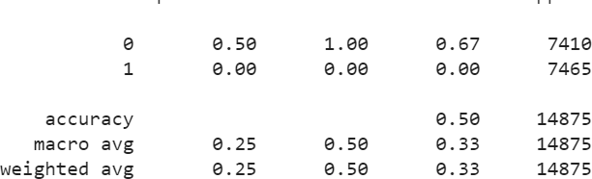

Figure 10. Classification report

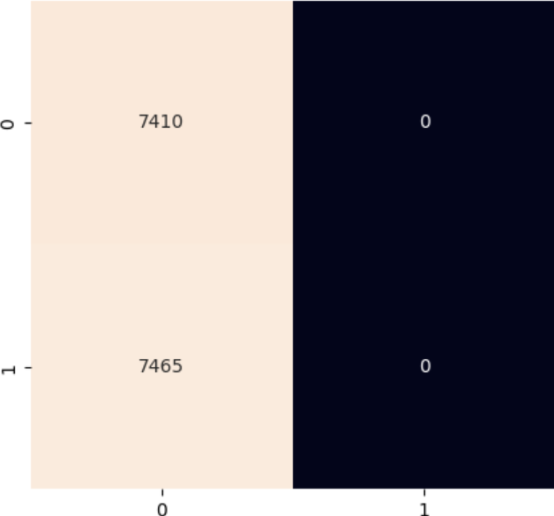

Figure 11. Confusion matrix

REFERENCES

1. Noor Latiffah Adam, Nor Hanani Rosli, and Shaharuddin Cik Soh. Sentiment analysis on movie review using na¨ıve bayes. In *2021 2nd International Conference on Artificial Intelligence and Data Sciences (AiDAS)*, pages 1–6, 2021.
2. K. Amulya, S. B. Swathi, P. Kamakshi, and Y. Bhavani. Sentiment analysis on imdb movie reviews using machine learning and deep learning algorithms. In *2022 4th International Conference on Smart Systems and Inventive Technology (ICSSIT)*, pages 814–819, 2022.
3. Egor Araslanov, Evgeniy Komotskiy, and Ebenezer Agbozo. Assessing the impact of text preprocessing in sentiment analysis of short social network messages in the russian language. In *2020 International Conference on Data Analytics for Business and Industry: Way Towards a Sustainable Economy (ICDABI)*, pages 1–4, 2020.
4. Shreya Arora, Tushar Bhatia, Stuti Rastogi, and Vijay Kumar Sharma. Comparison of various classifiers for movie data. In *2021 3rd Interna- tional Conference on Advances in Computing, Communication Control and Networking (ICAC3N)*, pages 138–140, 2021.
5. Khalid Ibnal Asad, Tanvir Ahmed, and Md. Saiedur Rahman. Movie popularity classification based on inherent movie attributes using c4.5,

part and correlation coefficient. In *2012 International Conference on Informatics, Electronics Vision (ICIEV)*, pages 747–752, 2012.

1. Rijul Dhir and Anand Raj. Movie success prediction using machine learning algorithms and their comparison. In *2018 First International Conference on Secure Cyber Computing and Communication (ICSCCC)*, pages 385–390, 2018.
2. Ayanabha Ghosh. Sentiment analysis of imdb movie reviews : A comparative study on performance of hyperparameter-tuned classifica- tion algorithms. In *2022 8th International Conference on Advanced Computing and Communication Systems (ICACCS)*, volume 1, pages 289–294, 2022.
3. Md. Rakibul Haque, Salma Akter Lima, and Sadia Zaman Mishu. Performance analysis of different neural networks for sentiment analysis on imdb movie reviews. In *2019 3rd International Conference on Electrical, Computer Telecommunication Engineering (ICECTE)*, pages 161–164, 2019.
4. Susmita S. Magdum and J. V. Megha. Mining online reviews and tweets for predicting sales performance and success of movies. In *2017 International Conference on Intelligent Computing and Control Systems (ICICCS)*, pages 334–339, 2017.
5. Meta Mahyarani, Adiwijaya Adiwijaya, Said Al Faraby, and Mahendra Dwifebri. Implementation of sentiment analysis movie review based on imdb with naive bayes using information gain on feature selection. In *2021 3rd International Conference on Electronics Representation and Algorithm (ICERA)*, pages 99–103, 2021.
6. D R Manjunath and Basavaraj S Hadimani. Hierarchical clustering and regression classification based review analysis on movie based applica- tions. In *2019 1st International Conference on Advanced Technologies in Intelligent Control, Environment, Computing Communication Engi- neering (ICATIECE)*, pages 214–219, 2019.
7. Saeed Mian Qaisar. Sentiment analysis of imdb movie reviews using long short-term memory. In *2020 2nd International Conference on Computer and Information Sciences (ICCIS)*, pages 1–4, 2020.
8. Sai Chandra Rachiraju and Madamala Revanth. Feature extraction and classification of movie reviews using advanced machine learning models. In *2020 4th International Conference on Intelligent Computing and Control Systems (ICICCS)*, pages 814–817, 2020.
9. Sara Sabba, Nahla Chekired, Hana Katab, Nassira Chekkai, and Mo- hammed Chalbi. Sentiment analysis for imdb reviews using deep learning classifier. In *2022 7th International Conference on Image and Signal Processing and their Applications (ISPA)*, pages 1–6, 2022.
10. Tirath Prasad Sahu and Sanjeev Ahuja. Sentiment analysis of movie reviews: A study on feature selection classification algorithms. In *2016 International Conference on Microelectronics, Computing and Communications (MicroCom)*, pages 1–6, 2016.
11. Irum Sindhu. and Faryal Shamsi. Prediction of imdb movie score movie success by using the facebook. In *2023 International Multi-disciplinary Conference in Emerging Research Trends (IMCERT)*, volume I, pages 1–5, 2023.
12. Kamil Topal and Gultekin Ozsoyoglu. Movie review analysis: Emotion analysis of imdb movie reviews. In *2016 IEEE/ACM International Conference on Advances in Social Networks Analysis and Mining (ASONAM)*, pages 1170–1176, 2016.
13. Tina Esther Trueman, Ashok Kumar Jayaraman, Erik Cambria, Gayathri Ananthakrishnan, and Satanik Mitra. An n-gram-based bert model for sentiment classification using movie reviews. In *2022 International Conference on Artificial Intelligence and Data Engineering (AIDE)*, pages 41–46, 2022.
14. Alec Yenter and Abhishek Verma. Deep cnn-lstm with combined kernels from multiple branches for imdb review sentiment analysis. In *2017 IEEE 8th Annual Ubiquitous Computing, Electronics and Mobile Communication Conference (UEMCON)*, pages 540–546, 2017.
15. Ling Zhang, Miao Wang, Ming Liu, and Haozhan Li. Sentiment analysis of movie reviews based on lstm-adaboost. In *2022 IEEE 5th Advanced Information Management, Communicates, Electronic and Automation Control Conference (IMCEC)*, volume 5, pages 186–190, 2022.